Who Will Benefit from Kindergarten Readiness?  Any child turning 5 between July 2022 and December 2022. A child deserving of time and space to allow for further cognitive, social, and emotional and physical growth to be more prepared to enter Kindergarten.  Curriculum  Phonemic Awareness, Phonological Awareness, Handwriting without Tears, counting 1-20, Number Recognition through 20, Sort and Classifying, Patterning, Counting Objects, Responsive Classroom  Daily Schedule  Schedule: 9:00 AM-2:00 PM  9:00 – 9:20 AM: Free Play (drawing, coloring, morning work, morning jobs)  9:30 – 10:00 AM: Morning Meeting, Calendar  10:10-10:45 AM: Music and Movement, Snack  10:50-11:10 AM Letter Work/ Phonemic Awareness/ Phonological Awareness  11:15 AM-12:00 PM– Centers (4 timed centers)  12:00 -12:15 PM – Free Play  12:15-12:45 PM – Lunch  12:45 – 1:00 PM Quiet Time, Writing  1:00 – 1:30 PM – Math Instruction  1:30-2:00 PM– Free Play/ Closing Meeting  2:00 PM Dismissal |  | Testimonial…  “Our family has had the privilege of working with Ms. Meg for three years. The social and academic progress our daughter has accomplished is a testament to Ms. Meg’s talent at harnessing each individual child’s ability to learn.”  -Lauren Ferranti, parent of a student  “As a colleague of Meg’s, I can say that she is not only a highly qualified and knowledgeable preschool teacher, but she also makes learning fun by creating diverse, engaging environments for all abilities and backgrounds and always has open and on-going communication with parents.”  -Melissa Gladys, Special Education  Teacher, Hearing & Speech of WNY

Kindergarten Readiness Program
Extension of A Sweet Start Preschool
Sweet Charlotte’s

 |  |   “Childhood is a journey not a race.” |  | 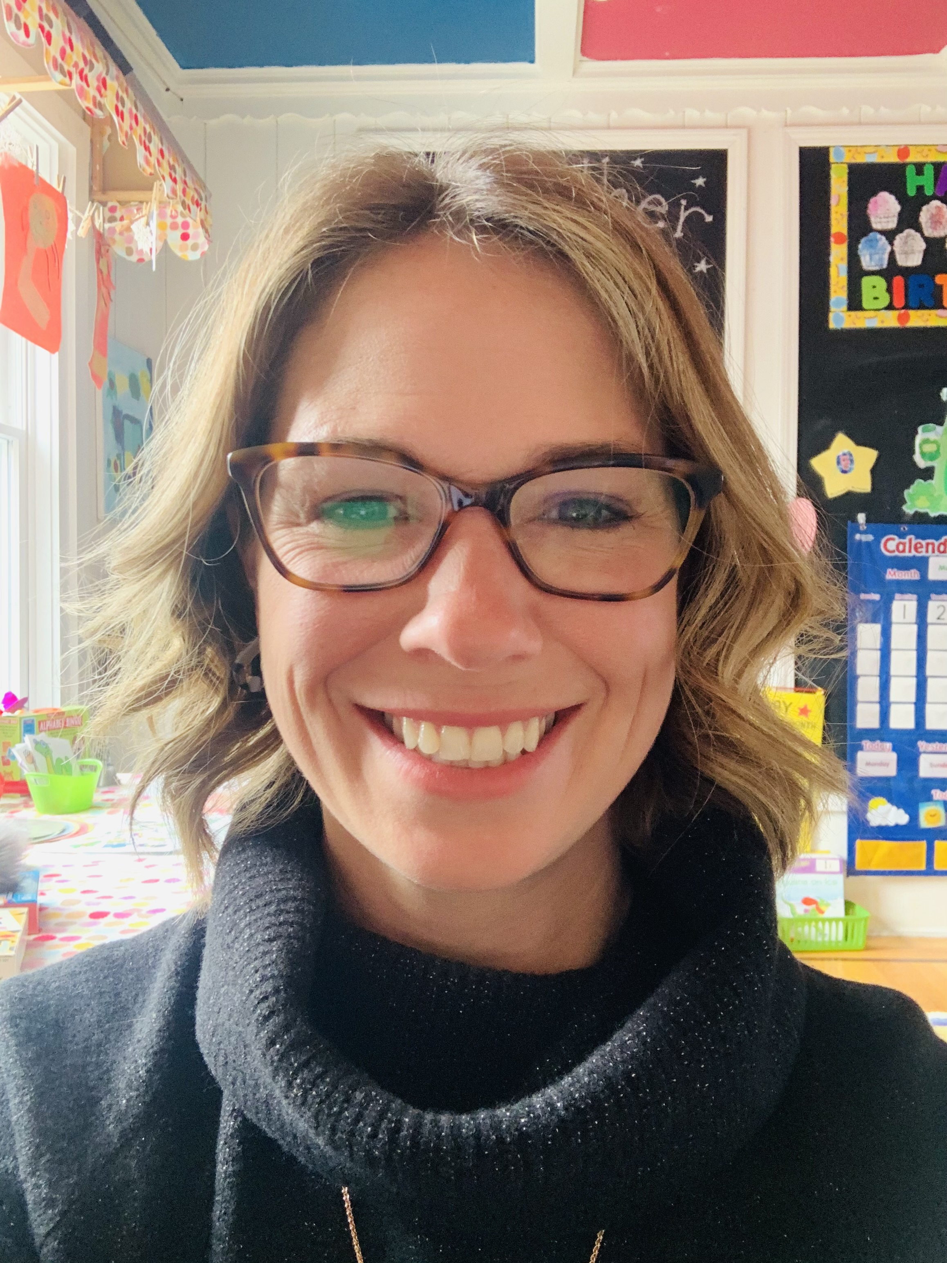
Details of the Program  -4 Full Days Per Week 9 AM-2 PM  -Bring in lunch  -September 2022- June 2023  -Tuition: $6200.00  -Contact: kreadinesssc@gmail.com  -Location: Sweet Charlotte’s  10255 Main Street  Clarence, NY 14031    www.sweetcharlottes.org |  |  |  | Meet Ms. Meg  Over the last 17 years Ms. Meg has taught Kindergarten and Universal Pre-K, with a focus on Special Education with preschool students for the most recent 10 years. This past year was her first year as the Kindergarten Readiness teacher. She is a passionate educator, providing children a strong foundation of learning by developing their cognitive, social and emotional skills, and creating a lifelong passion for learning.  She lives in Clarence with her husband and three children. You may also see her at Clarence Soccer Center where she spends a lot of time doing her other passion coaching soccer.

